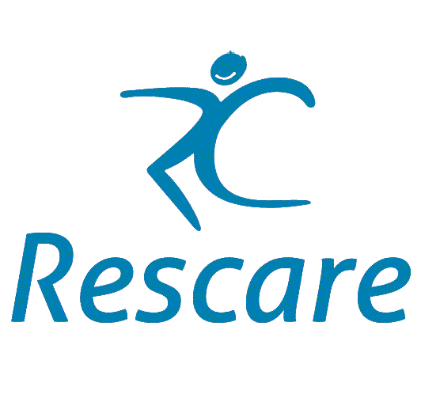
In summary

- Obesity is a serious problem for people with learning disability
- Eating is not just about nutrition
- Choice should be informed not blindly following an expressed whim
- Healthy eating habits can take months to form
- An interest in food and cooking is beneficial
- Prevention of obesity is about the whole style of living
- Carers are the key to good practice

Background

A report from Public Health England in 2013 on Obesity and Disability reported that obesity in adults is associated with the four most prevalent disabling conditions in the UK: arthritis, back pain, mental health disorders and learning disabilities. It is estimated that around 23% of children with learning disabilities are obese there is evidence that rates of obesity in adults with learning disabilities can be up to 50%. Physical inactivity, unhealthy diets, and weight gain from medication are all factors that contribute to the problem. This matters because heath implications can be can be profound.

However there is minimal evidence from controlled studies on which obesity interventions are effective for individuals with disabilities. This lack of evidence contributes to the inequalities around outcomes and accessing services experienced by individuals with these conditions¹

As noted in the Public Health England 2020-2025 strategy poor diets and excess body weight deprive people in England of more than 2.4 million life years through premature mortality, illness and disability each year. There are close links to broader social disadvantage, such as poverty, poor housing and social isolation, which is experienced disproportionately by people with learning disabilities. ². General practitioner learning disability registers are rarely complete. In 2018 only around a quarter to a third of the estimated number of people with a learning disability were on a GP register. This means appropriate adjustments to their health care cannot be delivered – for example unless a person is on a GP learning disability register they are not eligible for a learning disability annual health check.³ Annual health checks are a vital tool in monitoring health and wellbeing and so identifying potential problems in weight before ill health strikes.
Being obese puts people at much greater risk of many important health problems including:
- heart disease
- high blood pressure
- strokes
- diabetes
- several types of cancer
- mobility difficulties⁴

Despite the limited amount of evidence from controlled studies fortunately there is a considerable body of well found guidance from credible sources.

Capacity and choice around diet and physical activity⁴
People with learning disabilities or their families and care services often mention issues about capacity and choice around diet and physical activity as being difficult, this can include:
- supporters such as family or staff struggling to contribute to best interest decisions
- dilemmas about balancing choice and the duty of care and balancing different risks and benefits
- paid supporters can feel limited in their capacity to influence food choices
- supporters misusing the right to make unwise decisions as an excuse for not helping the person to understand risks and options properly

Risk assessment issues have been identified as one of the main barriers to physical exercise. The Health Equalities Framework ⁴ offers a tool that can be used by support workers and health practitioners, as well as people with learning disabilities and their family carers, to discuss risks to health and wellbeing. It encourages discussion about balancing risks: for example, the risks posed by being overweight alongside the risks of limiting choice.

Practical Advice from the Caroline Walker Trust⁵

From: Eating well: children and adults with learning disabilities Nutritional and practical guidelines The Caroline Walker Trust, 2007 ISBN 978-1-89-782023-0 Reproduced with permission

Philosophy of care – rights and responsibilities

● Managers and support staff should be aware of the code of practice of the Mental Capacity Act 2005 which presumes that anyone over the age of 16 has the right to make his or her own decisions and must be assumed to have the capacity to do so unless proved otherwise, and that people should be supported to make their own decisions and choices.

Helping people make good choices

● A variety of foods and drinks should be made available to everyone and support staff should be trained and supported to help people with learning disabilities make informed choices. Where there are communication difficulties around food and drink choices and eating, support staff should be encouraged to develop skills in interpreting people’s wishes.

● Courses on nutrition and health and on basic cookery for people with learning disabilities, and for their friends and family, should be made available. Special courses for those people with learning disabilities who are parents should also be made available.

Organisational culture

● In all settings it is essential that there is a commitment to good nutrition and an awareness of the wider role of food and drink in contributing to wellbeing and quality of life. Managers and staff at all levels need to demonstrate their commitment to good nutrition by ensuring everyone receives adequate training and support.

● Efforts should be made to find out about the food preferences and eating patterns of people with learning disabilities – including those who move into new or residential settings, regardless of how long they will stay there. This information should be recorded, shared with all support staff, and regularly updated.

● People with learning disabilities should be encouraged to include information about food and nutritional health in their health action plan which is compiled to explain their health needs, and in all care plans.

Staff training and support

● The importance of staff training cannot be over-emphasised. In order that children, young people and adults with learning disabilities are supported to eat and drink well, it is essential that everyone involved in supporting them has a clear idea about what eating well means in practice and that appropriate training is on-going for all staff, regardless of whether they are permanent, temporary, employed through an agency or involved in a voluntary capacity
.
● It is important that anyone who supports those who need assistance with eating is trained to help in a sensitive and efficient way. Helping someone with eating difficulties to eat can be complex and stressful and it is essential that staff are given sufficient support from colleagues when this is challenging.

Involving and listening to family and friends

● A real partnership between families, friends and support staff is essential so that everyone works together to ensure that each individual eats and drinks in a way that they prefer and which is appropriate, safe and health-promoting. In residential and day care settings it is important that adequate notice of, and the reasons for, changes to meals and snacks are given to everyone so that people can comment on and discuss the changes before they are introduced. ⁵

https://www.cwt.org.uk/wp-content/uploads/2015/02/EWLDGuidelines.pdf for full text

Rescare’s advice to people with learning disabilities and/or their carers:
● Ensure you are on the GP register of people with Learning Disability. Ask for your annual health check with the GP – you are entitled to it, and you will incidentally contribute to an improved accuracy of the statistics used by the NHS and others.
● Ask your GP or psychiatrist for regular reviews of your medication. It’s your right, and it’s the recommendation of STOMP (‘Stopping over medication of people with a learning disability, autism or both’)
● Enquire about vaccinations for Covid and ‘flu – you are entitled to them.
● Arrange an eye-test every two-years (If you receive benefits, you will probably be entitled to this free of charge)
● Insist that health staff make reasonable adjustments to enable what may be stressful, confusing or intrusive procedures (injections, blood tests, eye tests etc.) to take place.⁶

Finally we refer you to two appendices:

Appendix I for other useful information previously prepared by Rescare

(Available at… https://www.rescare.org.uk/wp-content/uploads/2021/03/Obesity-and-Choice-Forum-appendix-I.docx )

and

Appendix II (reproduced with permission) is an account of a very successful model is described by Dr Marcus van Dam, who is a GP based at Danby Surgery, North Yorkshire
(Available at…https://www.rescare.org.uk/wp-content/uploads/2021/03/Obesity-and-Choice-Forum-appendix-II.pdf )

He describes an integrated way of living at Botton Village with many clear health benefits. He says:

We have seen important and relevant outcome data and the results are extremely positive. One could say that Botton has slashed the rate of obesity and mental illness by a half! There is nothing I could prescribe that would be even nearly as effective. So how did they do it? Why were so relatively few people in Botton obese or have depression, anxiety or challenging behaviour? The answer has to do with what we call the social determinants of health, which we have of course all heard about: a healthy diet, physical activity, a social network etc.

Sources

¹https://www.nice.org.uk/guidance/cg189/evidence/obesity-update-appendix-l-pdf-6960327446

²https://www.gov.uk/government/publications/phe-strategy-2020-to-2025#:~:text=The%20PHE%20Strategy%202020%20to,over%20the%20next%205%20years

³https://www.nhs.uk/Scorecard/Pages/IndicatorFacts.aspx?MetricId=640&orgType=null

⁴ https://www.gov.uk/government/publications/obesity-weight-management-and-people-with-learning-disabilities/obesity-and-weight-management-for-people-with-learning-disabilities-guidance

⁴ https://www.ndti.org.uk/resources/publication/the-health-equality-framework-and-commissioning-guide1

⁵https://www.cwt.org.uk/wp-content/uploads/2015/02/EWLDGuidelines.pdf info@cwt.org.uk<

⁶https://www.england.nhs.uk/rightcare/2017/11/21/the-need-for-reasonable-adjustments-for-people-with-a-learning-disability-and-diabetes/

